**2025 Competition Cook Teams**

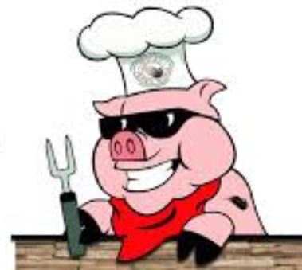

Bayou BBQ

Berkeley Shrine Club

Dorchester Shrine club

Monkey Bottom Butts

Ultimate Tailgaters

We like big butts

Omar Drifters

Omar VIP

Hog Wild Neighbors

Back Draft BBQ

Hog Tide BBQ

Twisted BBQ

3 Smoking Gnomes BBQ

Team Pioneer

Parkers Pits

Bootleggers

Bulls BBQ

On the Que BBQ.

Sweet Willie T’s.

Fat Bottom Grills