2023 Competition Cook Teams
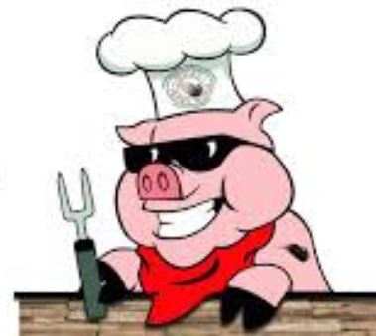

“Ultimate Tailgaters BBQ”
“Fu Man Que”
“We Like Big Butts”
“VIP Escorts”
“PAPA’s Que”
“On The Que BBQ”
“Hog Wild Neighbors”
“Southern Que & Stew”
“OMAR Cowboys”
“Dorchester Shrine club #1”
“Dorchester Shrine club #2”
“Backdraft BBQ SC”
“The Pit Warriors”
“Bootleggers BBQ”
“The Smoked Pig”
“Coastal Produce BBQ”
“Sticks and Coal BBQ”

