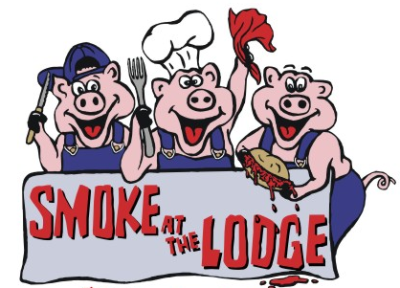

SUMMERVILLE MASONIC LODGE No. 234

CORPORATE SPONSORSHIP ENTRY

Proceeds help to support the following local charities: Dorchester County Community Outreach
(Keys to Change for Men, Anchor House) (Keys to Change for Women Light House) ( Musc, Shriners Hospital for Children transportation fund ) (Dorchester Paws) and the (Summerville OES). Please visit the links to their web sites at "Charity for SATL 2026" at www.SummervilleLodge.net

BUSINESS NAME: _______________________________________________________________

ADDRESS: _______________________________________________________________

CITY: __________________________ STATE: _________ ZIP: _____________

CONTACT PERSON: __________________________ PHONE: ______________________

SOLD BY: __________________________ EMAIL: ______________________

AMOUNT: __________________

MAKE CHECKS PAYABLE TO: SMOKE AT THE LODGE

PLEASE RETURN COMPLETED SPONSORSHIP FORM WITH CHECK TO:

Smoke at the Lodge
P.O. Box 733
Summerville, SC 29484 – 0733

Summerville Masonic Lodge No. 234 is presenting “SMOKE AT THE LODGE”, our 21st Annual BBQ Competition, Dinner and Fundraising event, on March 27 & 28 2026, at the Summerville Masonic Lodge located at 111 Main Street next to the railroad tracks.

$100 Sponsorships include four (4) complimentary tickets for BBQ dinners at the Lodge’s annual BBQ dinner sale on Saturday, March 28th. Sponsors will also receive name recognition on our Sponsor Board and on our website www.summervillelodge.net In order to give our sponsors adequate recognition for their generosity, our website remains up throughout the year.

$500 Sponsorships include twenty (20) complimentary tickets for BBQ dinners at the Lodge’s annual BBQ dinner sale on Saturday, march 28th. Sponsors will also receive a frame certificate for their donation and name recognition in our ads, on our Sponsor Board and on our website www.summervillelodge.net. In order to give our sponsors adequate recognition for their generosity, our website remains up throughout the year.

$1,000 Sponsorships are also available. Contact Chris Caron, 843-437-4540, ccaron728015@yahoo.com.com find out more details about this sponsorship level go to www.summervillelodge.net Please come and join the festivities both Friday and Saturday for the cook off, judging, and dinner. Visit our website for further details.

WE APPRECIATE YOUR SUPPORT OF THIS EVENT!

