SUMMERVILLE MASONIC LODGE No. 234
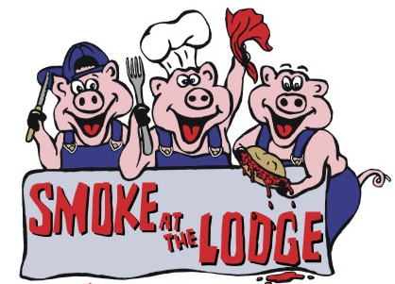
2024 - OFFICIAL ENTRY FORM
Event Dates: April 5th & April 6th, 2024

Please Print Official Team Name: _______________________________________________________________

To Whom do you want the Check made out if one is deserved:_______________________________________

Head Cook’s Name: (#1) ____________________________________ Phone No.: ______________________

Mailing Address: ____________________________________________________________________________

City: __________________________________ State: _________________ Zip Code: _______________

Email Address: ______________________

Team Members’ Names: (#2) ______________________________ (#3) _______________________________

(#4) ______________________________

Smoke at the Lodge (SATL) reserves the right to reject any application. For applications that are not accepted, SATL will return the application fee. However, there will be no fee refunds after the application has been taken and accepted for the contest. Any photos taken of your team become the property of the Summerville Masonic Lodge and may be used for promotional purposes. PLEASE REMEMBER NO PETS OR ALCOHOL ALLOWED.
Contestants agree to indemnify and hold Summerville Masonic Lodge, its employees, agents, sponsors, and volunteers harmless from any claims against Summerville Masonic Lodge, its employees, agents, sponsors, and volunteers, including, without limitation, all costs, liabilities, judgments, expenses, damages, or reasonable attorney’s fees arising out of or in connection with (1) any structure erected by contestants, (2) any apparatus, equipment, or personal property used by contestants, (3) any act of omission on the part of contestants, its agents, invitees, participants, representatives, employees, and servants, and (4) any claims made on account or resulting from contestants’ participation in the contest.
The teams competing will include both the Pork and RIB category with the RIBs being an option. The entree fee is $250, and checks must be received along with the entry form and postmarked or hand-delivered no later than March 15, 2024.

Please indicate your participation in the following discretionary events:
"No Pork Night" (no charge): Yes____ No____ Ribs: (no charge) Yes____ No____

For additional questions, please email us at www.summervillelodge.net or contact:
Tom Clemons Jvssville@aol.com Phone 843-991-1012
Brent Turner Turnerbrent1971@gmail.com Phone 843 514-3556

Checks should be made payable to: SMOKE AT THE LODGE

Complete this form and mail, along with the entry fee, to: SMOKE AT THE LODGE
P.O. Box 733
SUMMERVILLE, SC 29484-0733

_______________________________________________ ______________________
Head Cook’s Signature (Required) Date

