Smoke At the Lodge 2024
Summerville Masonic Lodge No. 234
Annual Charities $10,000+

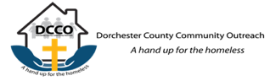
DCCO – Two Homes One Mission (dcco4homeless.org)
Hope’s House – DCCO (dcco4homeless.org); Home of Hope – DCCO (dcco4homeless.org)
In June of 2019, we successfully finished the renovations of 700 Central Ave, Hope's House. This will serve as our newest facility, a safe place for women who are experiencing homelessness. At the end of 2022, Hope's House had assisted over 25 women with a safe, welcoming, supportive place to live.

We Are Proud To Say That 100% Of Net Proceeds Go Towards Fulfilling A Child's Wish.
https://carolinasunshine.org
Carolina Sunshine For Children provides a ray of sunshine for South Carolina children with life-threatening illnesses. When a wish comes true, a child's beaming smile can be a positive, lasting memory for families going through difficult times.
Founded in 1983, Carolina Sunshine For Children is a non-profit group operating solely for the benefit of the children and families of South Carolina. We are proud to say that 100% of net proceeds go towards fulfilling a child's wishes.
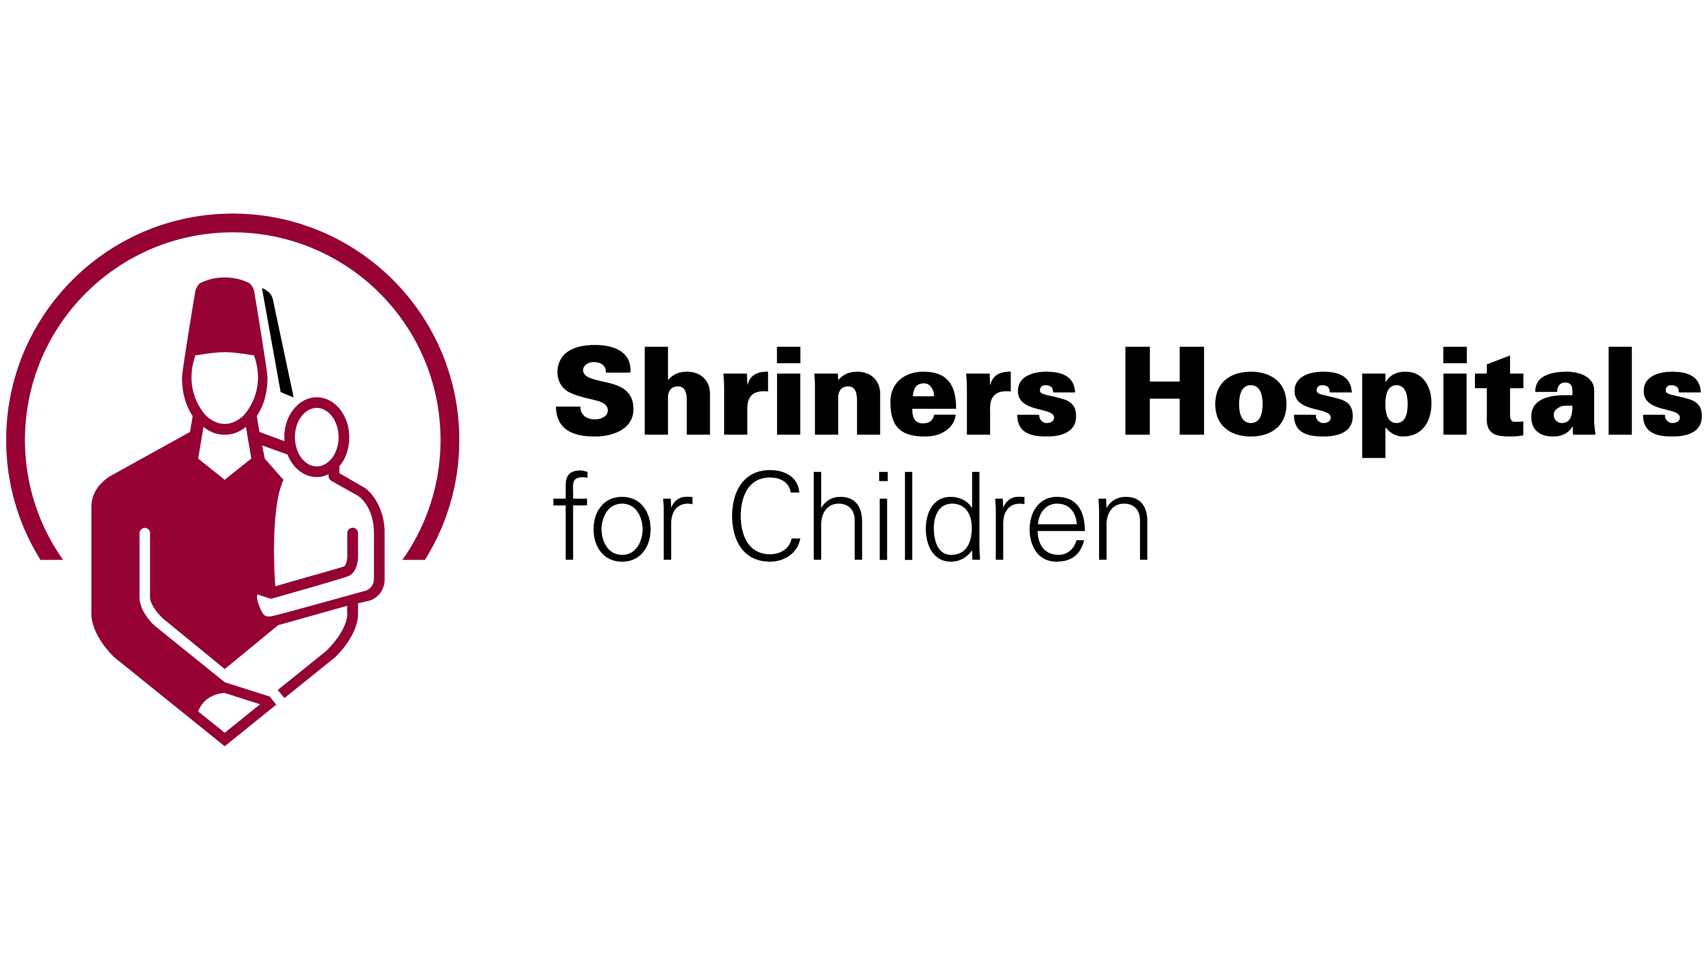
https://www.shrinerschildrens.org/en/

Shriners Children’s three-part mission has one goal: to change and improve lives

We do this by caring for our patients, conducting research to gain knowledge and develop new treatments, and providing educational opportunities for physicians and other healthcare professionals.

Both patients and health care professionals find they have entered a very special place when they step into Shriners Children’s. From the first moment, the experience is different. Our compassionate, patient-centered atmosphere immediately sets a tone of hope for the families who come to us.

At Shriners Children’s, we strive to help each patient achieve the best possible outcome. Our commitment to research helps us find new and improved treatments and contribute to the world’s medical knowledge. We continue to pursue seminal, cutting-edge discoveries that will help our patients live full and rewarding lives.

Another way we help children everywhere is by helping to educate health care professionals. Shriners Children's offers educational opportunities in a variety of specialties, through courses, lectures, seminars and workshops. In addition, our physicians and clinicians are known for sharing their experience and knowledge with medical communities around the world, so that more children may be helped closer to where they live.

