SUMMERVILLE MASONIC LODGE No. 234
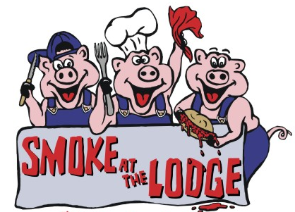
CORPORATE SPONSORSHIP ENTRY

Proceeds help to support the following local charities: Dorchester County Community Outreach (Home of Hope and Hopes House), and Jimmy V Foundation. Please visit the links to their web sites at "Charity for SATL 2023" at www.SummervilleLodge.net

BUSINESS NAME: _______________________________________________________________

ADDRESS: _______________________________________________________________

CITY: __________________________ STATE: _________ ZIP: _____________

CONTACT PERSON: __________________________ PHONE: ______________________

SOLD BY: __________________________ EMAIL: ______________________

AMOUNT: __________________
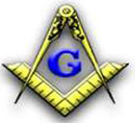
MAKE CHECKS PAYABLE TO: SMOKE AT THE LODGE
PLEASE RETURN COMPLETED SPONSORSHIP FORM WITH CHECK TO:

Smoke at the Lodge
P.O. Box 733
Summerville, SC 29484 – 0733

Summerville Masonic Lodge No. 234 is presenting “SMOKE AT THE LODGE”, our 18th Annual BBQ Competition, Dinner and Fundraising event, on March 31, 2023- April 1, 2023, at the Summerville Masonic Lodge located at 111 Main Street next to the railroad tracks.

$100 Sponsorships include four (4) complimentary tickets for BBQ dinners at the Lodge’s annual BBQ dinner sale on Saturday, April 1st. Sponsors will also receive name recognition on our Sponsor Board and on our website www.summervillelodge.net In order to give our sponsors adequate recognition for their generosity, our website remains up throughout the year.

$500 Sponsorships include thirty (30) complimentary tickets for BBQ dinners at the Lodge’s annual BBQ dinner sale on Saturday, April 1st. Sponsors will also receive a plaque for their donation and name recognition in our newspaper ads, on our Sponsor Board and on our website www.summervillelodge.net. In order to give our sponsors adequate recognition for their generosity, our website remains up throughout the year.

$1,000 Sponsorships are also available. Please contact Jeff Greaves at 843-453-2640 JeffGreaves843@yahoo.com to find out more details about this sponsorship level go to www.summervillelodge.net

Please come and join the festivities both Friday and Saturday for the cook off, judging, and dinner. Visit our website for further details.

WE APPRECIATE YOUR SUPPORT OF THIS EVENT!

