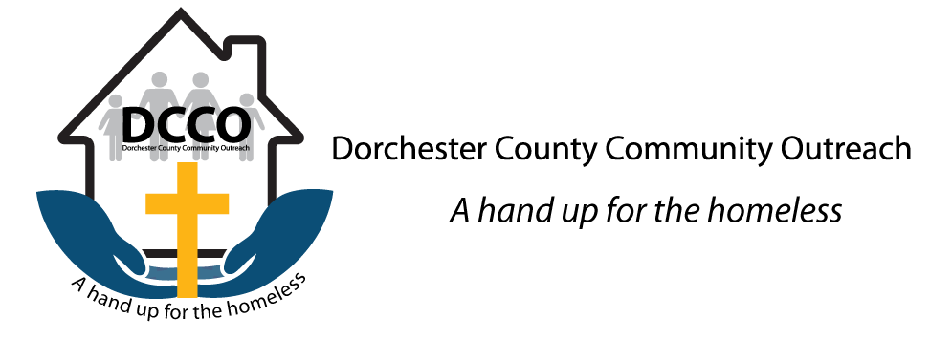
DCCO – Two Homes One Mission (dcco4homeless.org)
In June of 2019, we successfully finished the renovations of 700 Central Ave, Hope's House. This will serve as our newest facility, a safe place for women who are experiencing homelessness. At the end of 2019, Hope's House had already assisted over 25 women with a safe, welcoming, supportive place to live.
Hope’s House – DCCO (dcco4homeless.org)
Home of Hope – DCCO (dcco4homeless.org)

Cancer Foundation for Research | V Foundation
The V Foundation for Cancer Research has been fortunate to partner with many generous organizations and corporations who share our mission. We are proud to work with those who are dedicated to helping us realize Jim Valvano’s dream of defeating cancer.
Thanks to these collaborators, we’re able to fund essential research that can someday cure the more than 100 diseases that are collectively known as “cancer.”

